PROJECT REPORT TEMPLATE INTRODUCTION :

OVERVIEW :

Build an event management system using salesforce. This project helps in managing the ongoing and upcoming events in an organization.

PURPOSE :

Event management is the process of creating and maintaining an event. This process spans from the very beginning of planning all the way to post-event strategizing. All different branches of planning go into event management including various types of sourcing, designing, regulation checks, and on-site managements.

EMPATHY MAP :

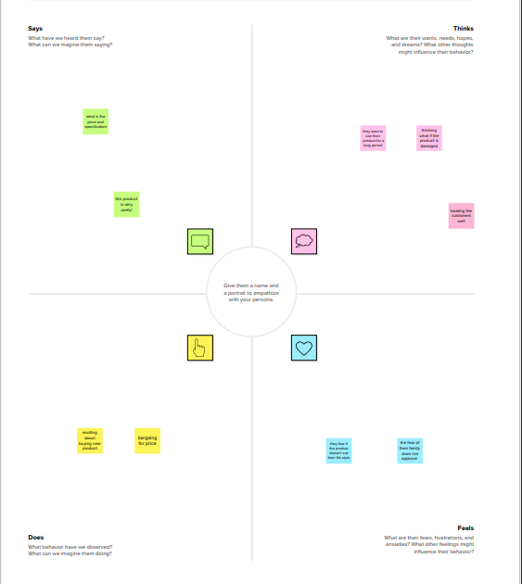

IDEATION & BRAINSTORMING MAP :

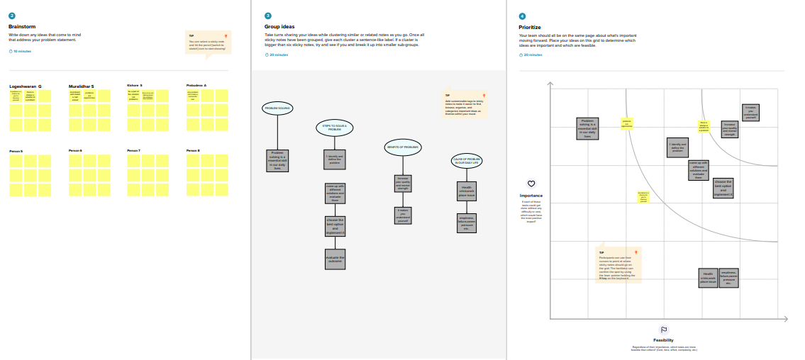

RESULT

DATA MODEL :

|  |  |  |
| --- | --- | --- |
| OBJECT | FIELD IN THE OBJECT | |
| FIELD LABEL | DATA TYPE |
| Event | Event name | Text |
| City | Text |
| Start Date | Date/Time |
| End Date | Date/time |
| Attendee | Attendee Name | Text |
| ID | Auto number |
| Email | Email |
| Phone | Phone |
| Speaker | Speaker Name | Text |
| Event Name | Lookup(event) |
| Bio | Text Area |
| Email | Email |

|  |  |  |
| --- | --- | --- |
| Vendors | Vendor Name | Text |
| Event Name | Text |
| Service Provider | Text |
| Email | Email |
|  | Phone | Phone |

ACTIVITY & SCREENSHORTS :

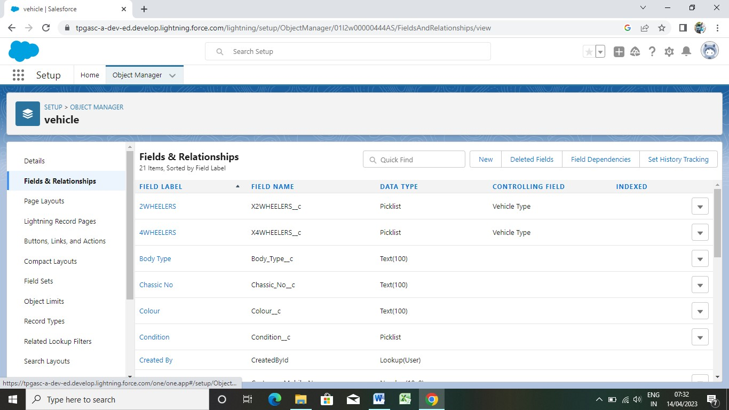

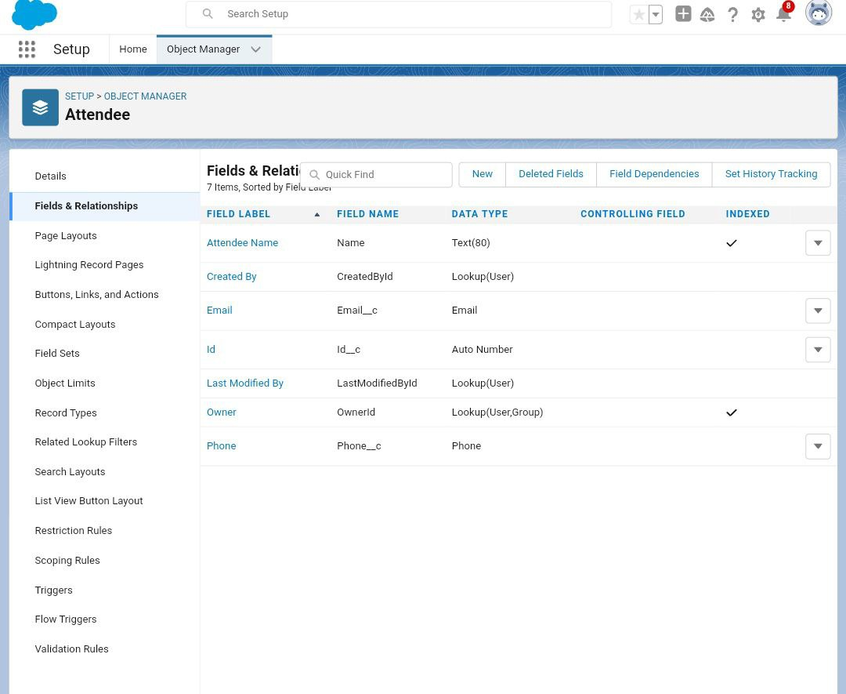 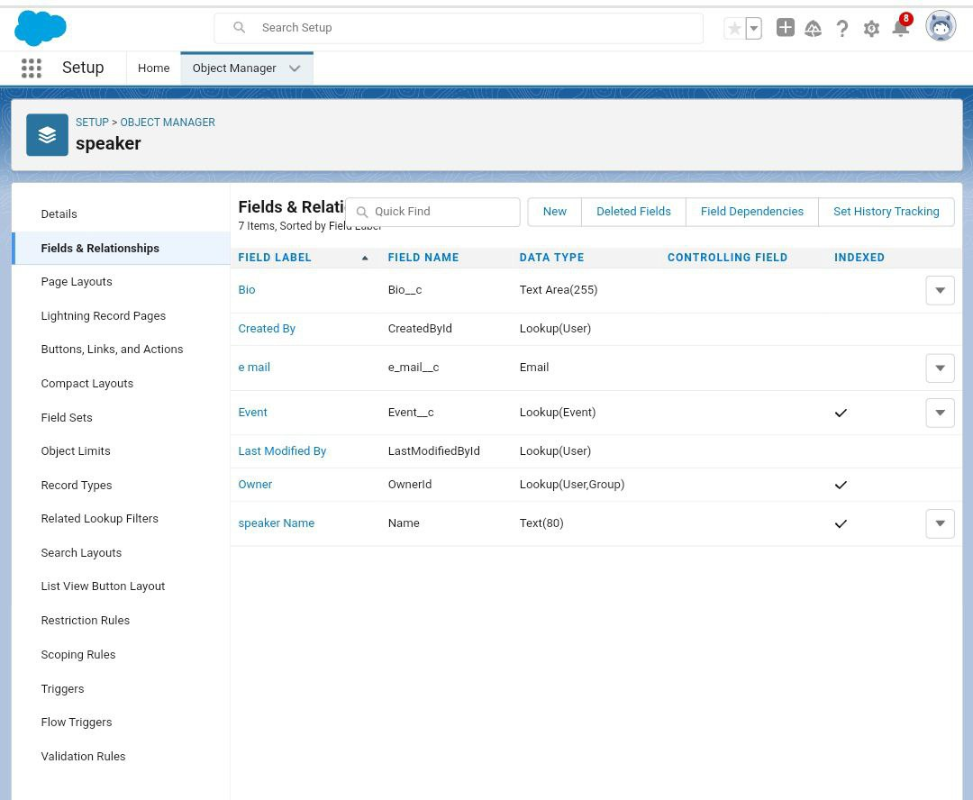

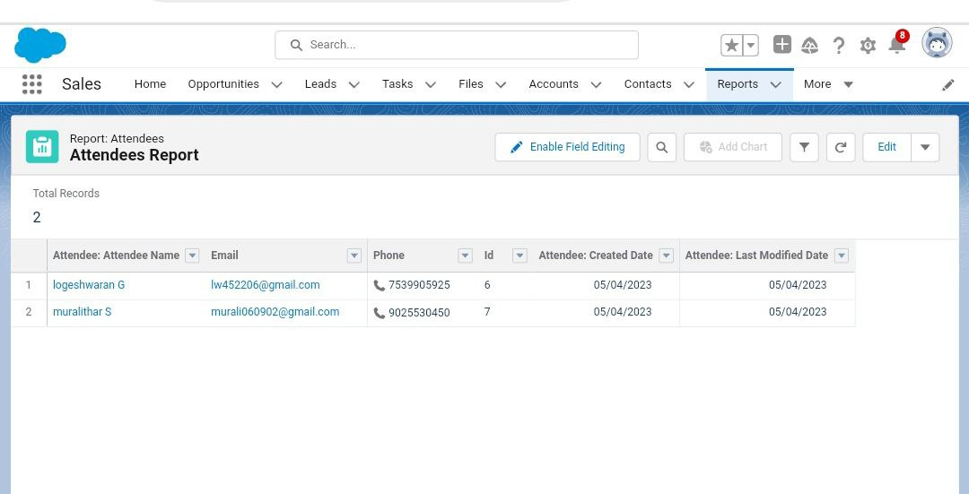

TRAILHEAD PROFILE PUBLIC URL :

Team Leader : <http://trailblazer.me/id/lganesan7lw>

Team member 2: https://trailblazer.me/id/msivakumar11

Team Member 3 : https://trailblazer.me/id/pdeva143

Team Member 4: https://trailblazer.me/id/skishore90

ADVANTAGES & DISADVANTAGES :

Event management system will make organising an event less stressful. It ensures it runs very smoothly. The Event management system saves time , cuts cost and increase engagement. When the event is over you can access personalised reports with lots of valuable informations. It reduces the possibilities of possible incidents that harms the atmosphere.

APPLICATION :

An event management system can be applied in many areas such as conferences, a product launch, interviews , a internal sales kick-off, or even a wedding . Any event that requires considerable planning and execution can use event management system .

CONCLUSION :

The main purpose for developing this project can helps to strategizing an event.

FUTURE SCOPE :

Event management is full of potential to grow large . Every event conduct by an organisation or for a personl event requires event management.